# 

## **DIPLOMA IN**

## **COMPUTER ENINEERING**

## **DONE BY**

## **K.PHANI SRI RAM**

## **M.DEVI SRI HARSHA**

## **M.NIFROSH**

## **K.RAVI TEJA**

UNDER GUIDANCE OF

U.SUSHMA

DEPARTMENT OF COMPUTER ENGINNERING

**AANM&VVRSR POLYTECHNIC GUDLAVALLERU**

**DEMENTIA** **PREDICTION**

Dementia :

Dementia refers to a set of symptoms that affect cognitive function, including memory, thinking, and behavior, impacting one's ability to perform daily tasks.

Symptoms :

Memory loss, language difficulties, impaired judgment, confusion, and behavioral changes are common symptoms of dementia.

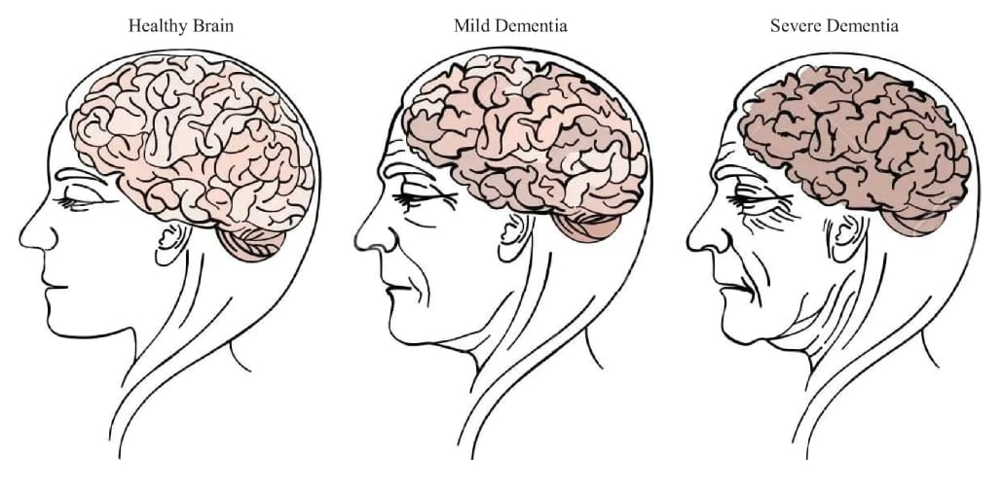

Pros:

1. Enhanced Creativity : Some individuals with certain types of dementia, particularly those affecting the frontal lobe, may experience a surge in creativity and artistic expression.

2. Living in the Present: With memory loss and cognitive decline, individuals with dementia may live more in the moment, appreciating simple joys without the burden of past regrets or future worries.

3. Strengthened Relationships: Caregivers and family members often develop stronger bonds with individuals with dementia through patience, empathy, and the sharing of precious moments.

4. Community Support: Dementia awareness initiatives and support groups provide resources, education, and a sense of community for individuals and families dealing with dementia.

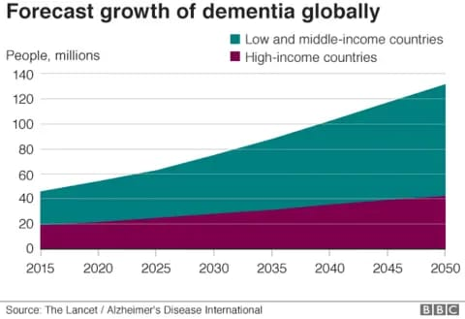

Cons:

1. Loss of Independence: Dementia can lead to a gradual loss of independence, affecting the ability to perform daily activities and making individuals reliant on caregivers for support.

2. Social Stigma: Misconceptions and stigma around dementia can lead to social isolation, discrimination, and misunderstanding, impacting the individual's mental well-being.

3. Emotional Distress: Both individuals with dementia and their caregivers may experience emotional distress, anxiety, depression, and frustration due to the challenges associated with the condition.

4. Financial Burden: The cost of dementia care, including medical expenses, home modifications, and professional caregivers, can impose a significant financial burden on families and impact long-term financial security.

5. Cognitive Decline: Progressive cognitive decline in dementia can lead to memory loss, confusion, disorientation, and difficulties in communication and decision-making, affecting overall quality of life.

6. Health Complications: Individuals with dementia are at higher risk of developing other health issues, such as infections, malnutrition, and physical injuries due to impaired judgment and coordination.